KR Dance Child Protection Policy & Procedures
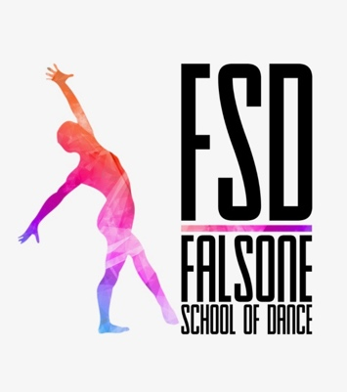
Child protection and Safeguarding policy

FSD Dance recognizes its duty of care under the Children and Young Persons Act 1963, the Child (Performances) Regulations 1968, the Protection of Children Act 1999 and the Criminal Justice and Court Services Act 2000. FSD Dance recognizes that abuse can take many forms, whether it be physical abuse, emotional abuse, sexual abuse or neglect. FSD Dance is committed to practice which protects children from harm. All staff members accept and recognize their responsibilities to develop awareness of the issues which cause children harm.

FSD Dance believes that:

KR Dance believes that:

- The welfare of the child/young person is paramount
- All children, whatever their age, culture, disability, gender, language, racial origin, religious beliefs and/or sexual identity have the right to protection from abuse.
- All suspicions and allegations of abuse should be taken seriously and responded to swiftly and appropriately.
- All members and employees should be clear on how to respond appropriately.

FSD Dance will ensure that:

KR Dance will ensure that:

- All children will be treated equally and with respect and dignity.
- The duty of care to children will always be put first.
- Enthusiastic and constructive feedback will be given rather than negative criticism.
- Bullying will not be accepted or condoned.
- All adults will demonstrate positive role modelling when dealing with other people.
- Action will be taken to stop any inappropriate verbal or physical behaviour.
- It will keep up-to-date with health & safety legislation.
- It will keep informed of changes in legislation and policies for the protection of children.
- It will undertake relevant development and training.
- It will hold a register of every child attending and will retain a contact name and number close at hand in case of emergencies.

Any person teaching for FSD Dance holds a DBS check, first aid, safeguarding and child protection certificate. FSD Dance has procedures in place to help any child who appears to be at risk or appears to be the victims of abuse. We will provide help and support if any child tells us they are affected by these issues. FSD Dance school’s principal Olivia Falsone is specifically responsible for children and child protection. She is the FSD Dance school child protection officer and can be contacted on 07931503901.

