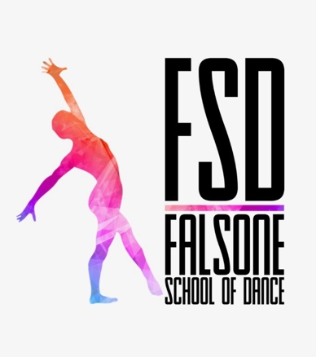
Privacy Policy
FSD Dance
The privacy of your personal information is very important to FSD Dance. We will not sell, rent or trade your personal information to any third party. We will take special care to protect the privacy and security of your information. This policy explains our information practices and the way that FSD Dance collects and uses your information. This Privacy Policy covers the information you provide to us offline and on the FSD Dance website.
HOW DOES FSD DANCE COLLECT AND USE MY INFORMATION?
When you register for classes at FSD Dance, our online booking system will collect contact information such as guardian names, addresses, phone numbers, emergency contacts, e-mail address and student information such as student names, birthdays, medical conditions, and your comments. Some of the information is required. This information is needed to manage studio business and will not be used or sold for any other purpose, except as described below. Some of the information is optional, optional information is requested to help us better understand our customers and is used only as needed for studio business. This information will not be used or sold for any other purposes, except as described below.
WHO HAS ACCESS TO MY INFORMATION?
FSD Dance personnel and teachers have access to your personal information only to manage the studio business.
FSD Dance will access your personal information and/or share it with third parties only for the following purposes: (i) as needed for studio business, including local councils and examination bodies; (ii) if required to do so by law or to comply with legal process; or (iii) to protect the rights, property, or personal safety of the public.
If you have any questions about our Privacy Policy or if you wish to update or remove any of your personal information, please contact Olivia from FSD Dance.

